# Flowchart

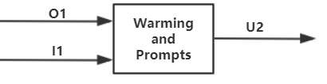

Figure Output block flowchart

## Unique identifiers

|  |  |
| --- | --- |
| Unique ID | Long Name |
| U2 | Simulation output |
| I1 | Simulation input state signal |
| O1 | Simulation state signal |

# Table of limits

|  |  |  |  |  |  |  |  |  |
| --- | --- | --- | --- | --- | --- | --- | --- | --- |
| Interaction | | Symbol | | Min. | Max. | | | Unit |
| -> U2 | | | | | | | | |
| *Data to normal users and administrators* | | | | | | | | |
| Limit output | | | | | | | | |
| Warning and prompts for wrong input or successful simulation | | - | | Successful simulation / WARNING… | | | | - |
| -> I1 | | | | | | | | |
| Simulation input state signal | - | | 0 | | 1 | | | - |
| -> O1 | | | | | | | | |
| Simulation state signal | - | | 0 | | | 1 | - | |